**Assignment Day 4**

1. Find out mail servers of following domain:
2. Ibm.com
3. Wipro.com

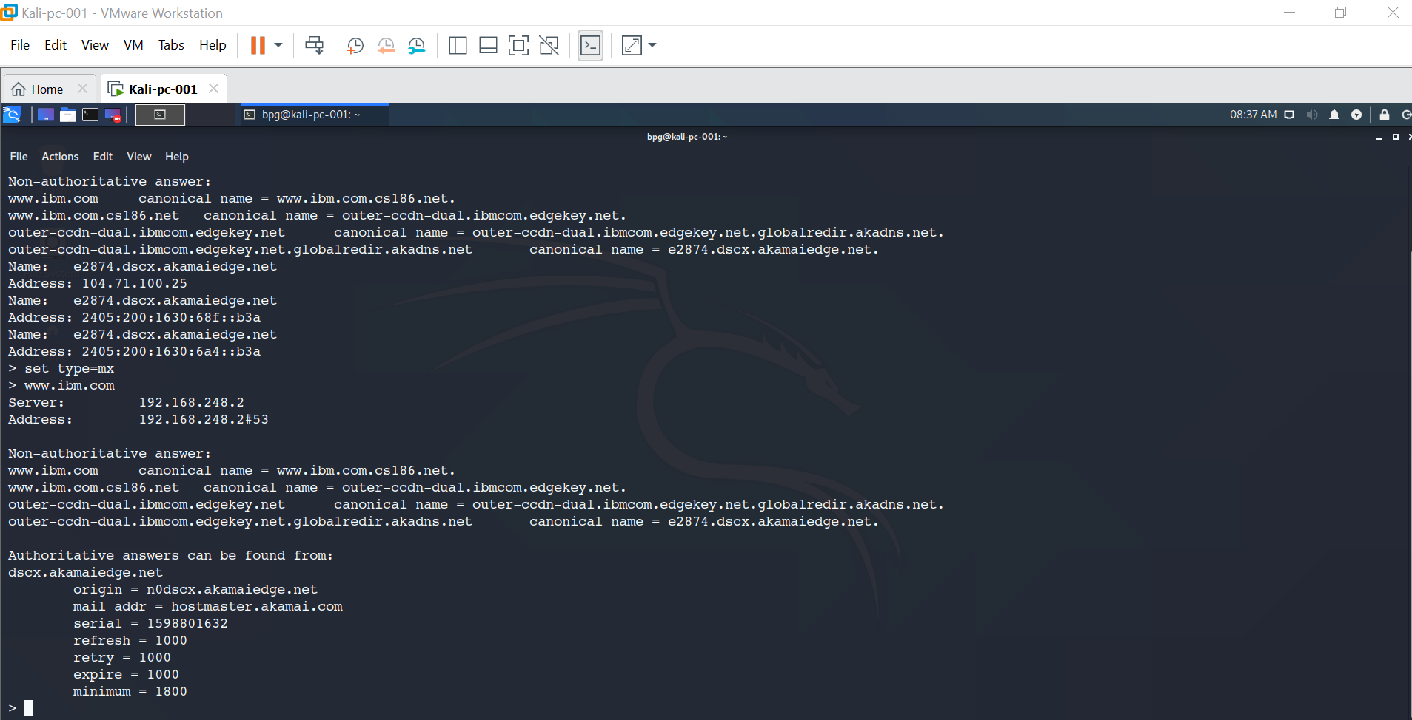

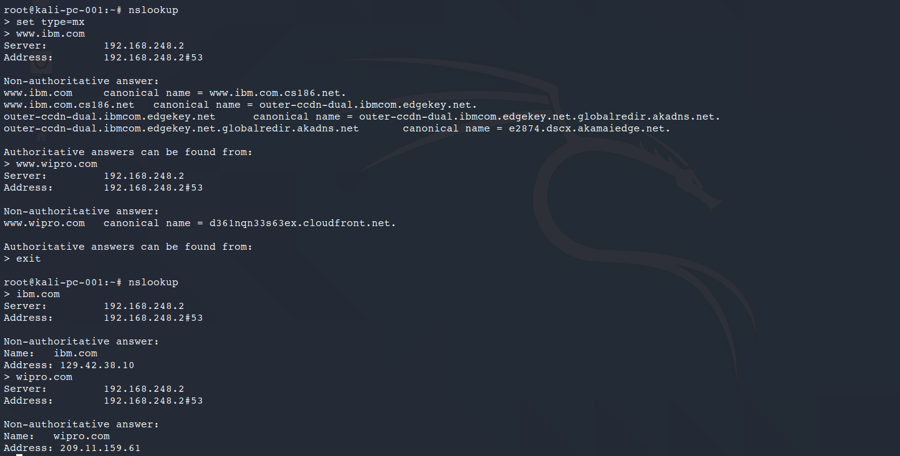

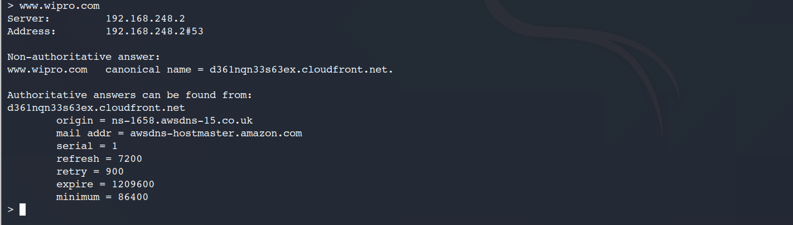

1. Find the location of these mails servers
2. Ibm.com

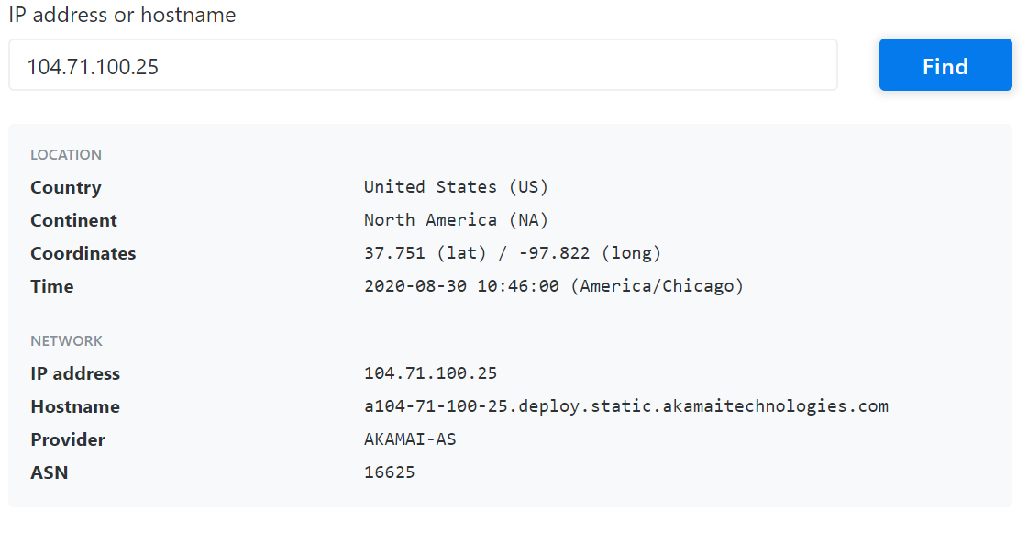

1. Wipro.com

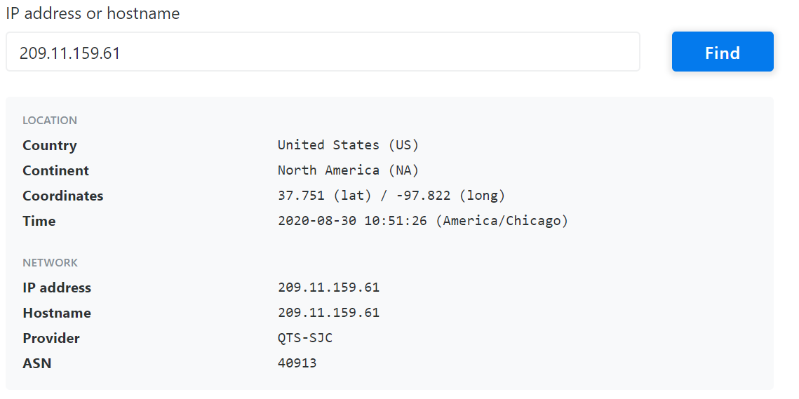

1. Scan & find out open ports 203.163.246.23

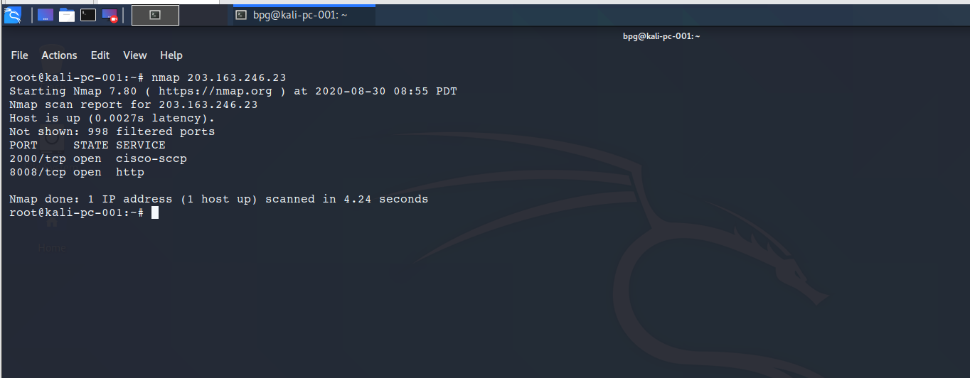

1. Install Nessus VM & Scan your system for CVE

